Brunswick Heads Chamber of Commerce Inc. ABN 19 217 506 370
________________________________________________________________________________

"Fostering a dynamic local business sector, and encouraging sustainable and innovative business development in line with the community’s vision for Brunswick Heads."
________________________________________________________________________________
BRUNSWICK VISITOR CENTRE MEMBERSHIP 2017
For tourism operators & all businesses servicing the Brunswick Valley area.
Renewal   New member   Date:_________________

Business Name ____________________________________________________________

Business Address ____________________________________________________________

Postal Address ____________________________________________________________

Applicant name(s) ____________________________________________________________

Phone ________________________ Fax _______________________________

Mobile _________________________________

Email _________________________________

Website Address _____________________________________________________________

25 word summary to describe your business: (for use on website and in promotions)

_____________________________________________________________________________________________________

_____________________________________________________________________________________________________

_____________________________________________________________________________________________________

MEMBERSHIP FEES including GST (1/1/17 – 31/12/17)
    $110.00 Annual membership fee    $60 - half year (from August)
    $45.00 Business Card Directory entry (discount if paid with membership)
    $100.00 E-marketing package including hyperlinks plus Weddings & Events listing

FOR EFT PAYMENT
Brunswick Heads Chamber of Commerce
BSB: 062665
A/C: 10025142
Ref: “Your Business Name”
CASH OR CHEQUE PAYMENT
Brunswick Heads Visitor Centre: 7 Park Street, Brunswick Heads
Postal Address: Brunswick Heads Chamber of Commerce
PO Box 184, Brunswick Heads 2483
_________________________________________________________________________________________________
Admin use only
Kristina Drapes (VC Membership): marketing@brunswickheads.org.au Data base   
Lisa Scheithe (Accounts) accounts@brunswickheads.org.au MYOB, Website

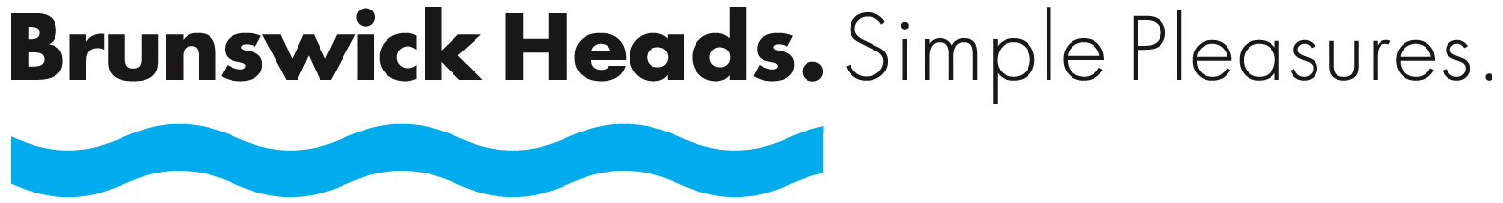

VISITOR CENTRE MEMBERSHIP – what’s in it for YOU!

This membership is designed for tourism and other businesses servicing Brunswick Heads visitors (accommodation providers, tours, attractions & activity operators).

WHAT ARE THE BENEFITS?
- 20% discount on our Simple Pleasures merchandise
- Free summary on the www.brunswickheads.org.au website, plus one image
- Opportunity to optimise your web presence on the Brunswick Heads website by selecting our
E-Marketing Package. Members receive discount ($100 instead of $110) and benefits include website hyperlinks to your own page, plus inclusion in the online Weddings & Events Bureau (if applicable).
- Discount on entry in Business Card Directory (distributed throughout Brunswick Heads & Ocean Shores)
- Free display of cards/brochures in Visitor Centre and referral service.
- Inclusion in the 101 Things to do in Bruns brochure (if applicable), updated annually.
- Inclusion in the Brunswick Heads Accommodation Guide (for accommodation providers), updated annually .

PLUS
- A Visitor Centre to welcome and look after your tourist customers, saving your business time.
- A voice representing the tourism operators/home based businesses servicing Brunswick.
- Advocacy to Council on tourism related / Home based business issues.
- Distribution of tourism information, workshop opportunities etc via e-newsletters.
- Special updates on issues such as Holiday Letting.
- Invitations to networking opportunities eg Free "Business After Hours", Home based Business Networking gatherings.
- Business development & educational information.
- Participation in collaborative marketing initiatives to showcase the town.
- Inclusion of stories submitted for the quarterly Village Voice e-newsletter.
- Protection of the town's character & point of difference through the Simple Pleasures branding campaign and Tourism Management Strategy.
- Strong partnerships with organisations beyond Brunswick (Destination NSW, Byron United, Byron Visitor Centre) to elevate our profile and secure grants.

MEMBERSHIP INFORMATION & FORMS: Visitor Centre 02 66851003 or marketing@brunswickheads.org.au

 

